**Lab 04 Home Tasks**

**21k-3881**

**Task 01**

package com.example.q1;  
  
import javafx.fxml.FXML;  
import javafx.scene.control.Label;  
import javafx.event.ActionEvent;  
import javafx.fxml.FXML;  
import javafx.scene.control.PasswordField;  
import javafx.scene.control.TextField;  
import javafx.scene.control.Alert;  
import javafx.scene.control.Alert.AlertType;  
public class q1control{  
 @FXML  
 private TextField txt;  
 @FXML  
 private PasswordField pas;  
 Alert al=new Alert(AlertType.*NONE*);  
 @FXML  
 void actionperfromed(ActionEvent ae) {  
 String u=txt.getText().toString();  
 String p=pas.getText().toString();  
 if(u.equals("hello")&&p.equals("123")){  
 txt.setText("");  
 pas.setText("");  
 al.setContentText("You are login!!!");  
 al.show(); }  
 else if(!u.equals("hello")&&!pas.equals("123")){  
 al.setAlertType(AlertType.*ERROR*);  
 al.setContentText("You are failed to login!!!");  
 al.show(); }  
 } }

package com.example.q1;  
import javafx.application.Application;  
import javafx.fxml.FXMLLoader;  
import javafx.scene.Parent;  
import javafx.scene.Scene;  
import javafx.stage.Stage;  
public class q1 extends Application {  
 @Override  
 public void start(Stage s) throws Exception{  
 Parent f=FXMLLoader.*load*(getClass().getResource("login.fxml"));  
 Scene t=new Scene(f);  
 s.setScene(t);  
 s.show(); }  
 public static void main(String[] args){  
 *launch*();  
 } }

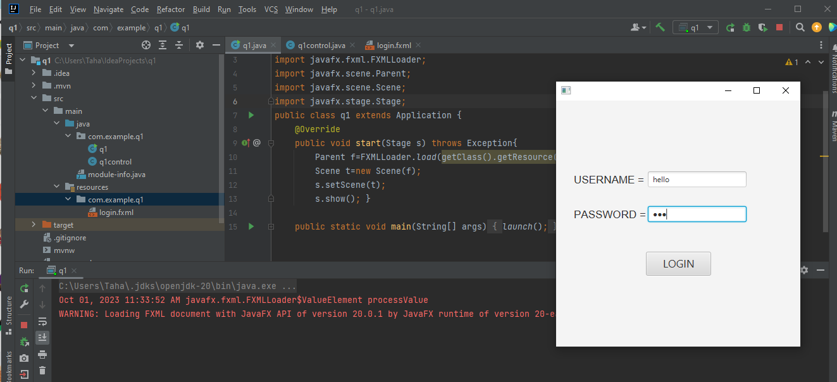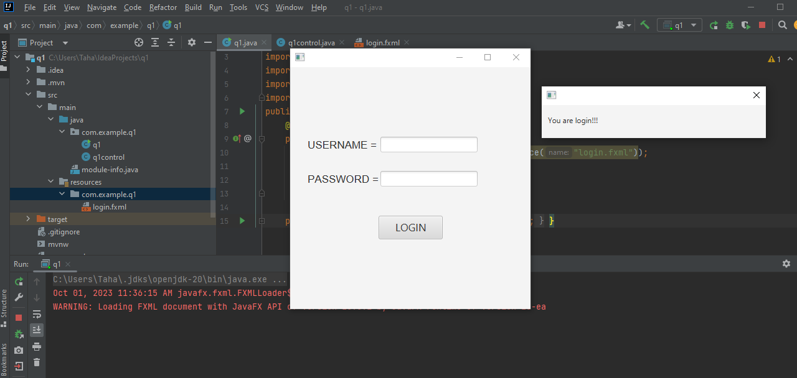

**Task 02**

package com.example.qe2;  
public class lc{  
 String t,a,g;  
 lc(String t,String a,String g){  
 this.t=t;  
 this.a=a;  
 this.g=g; }  
 public String getBtitle(){  
 return t; }  
 public void setBtitle(String t){  
 this.t=t; }  
 public String getBauther(){  
 return a; }  
 public void setBauther(String a){  
 this.a=a; }  
 public String getBgenre(){  
 return g; }  
 public void setBgenre(String g){  
 this.g=g; }  
}

package com.example.qe2;  
  
import javafx.collections.FXCollections;  
import javafx.collections.ObservableList;  
import javafx.collections.transformation.FilteredList;  
import javafx.collections.transformation.SortedList;  
import javafx.fxml.FXML;  
import javafx.fxml.Initializable;  
import javafx.scene.control.TableColumn;  
import javafx.scene.control.TableView;  
import javafx.scene.control.cell.PropertyValueFactory;  
import java.net.URL;  
import java.util.ResourceBundle;  
import javafx.scene.control.TextField;  
import javafx.event.ActionEvent;  
public class q2control implements Initializable{  
 @FXML  
 private TableColumn<lc, String> a;  
 @FXML  
 private TableColumn<lc, String> g;  
 @FXML  
 private TableColumn<lc, String> t;  
 @FXML  
 private TableView<lc> ta;  
 @FXML  
 private TextField ts;  
 ObservableList<lc> l=FXCollections.*observableArrayList*(  
 new lc("LINEAR ALGEBRA","ANTON","MATHS"),  
 new lc("LET US C","CEILE","PROGRAMMING"),  
 new lc("APPLIED PHYSICS","TAHA","ANY") );  
 @Override  
 public void initialize(URL url, ResourceBundle resourceBundle){  
 t.setCellValueFactory(new PropertyValueFactory<lc,String>("btitle"));  
 a.setCellValueFactory(new PropertyValueFactory<lc,String>("bauther"));  
 g.setCellValueFactory(new PropertyValueFactory<lc,String>("bgenre"));  
 FilteredList<lc> fl=new FilteredList<>(l,b->true);  
 ts.textProperty().addListener((observable, oldValue, newValue) -> {  
 fl.setPredicate(library -> {  
 if (newValue==null || newValue.isEmpty()){  
 return true; }  
 String loca = newValue.toLowerCase();  
 if (library.getBtitle().toLowerCase().indexOf(loca) != -1){  
 return true; }  
 else if (library.getBauther().toLowerCase().indexOf(loca) != -1){  
 return true; }  
 else if (library.getBgenre().toLowerCase().indexOf(loca) != -1){  
 return true; }  
 else  
 return false;  
 });  
 });  
 SortedList<lc> sl=new SortedList<>(fl);  
 sl.comparatorProperty().bind(ta.comparatorProperty());  
 ta.setItems(sl);  
 }  
 @FXML  
 void actionperformed(ActionEvent ae) {}  
}

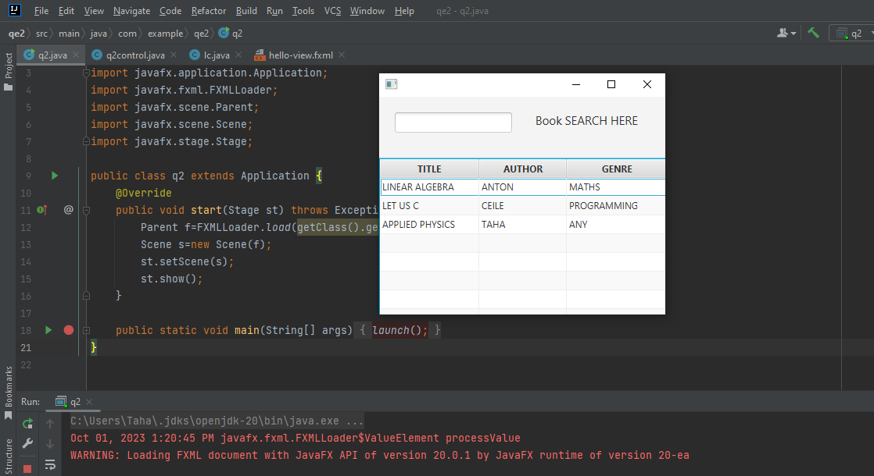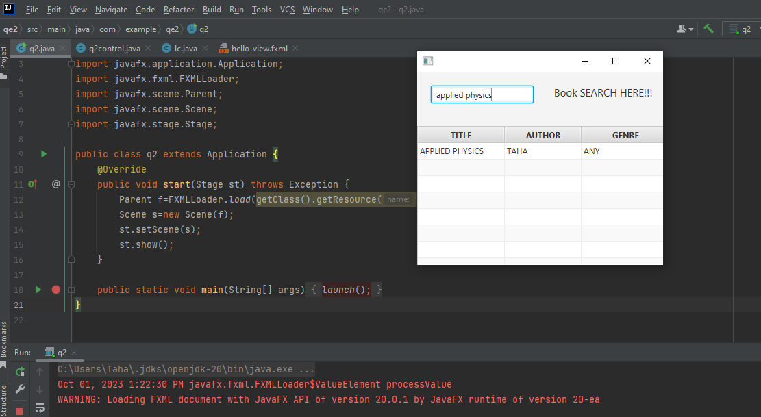

**Task 03**

package com.example.q3;  
import javafx.collections.FXCollections;  
import javafx.collections.ObservableList;  
import javafx.event.ActionEvent;  
import javafx.fxml.FXML;  
import javafx.fxml.Initializable;  
import javafx.scene.control.ListView;  
import javafx.scene.control.TextField;  
import java.net.URL;  
import java.util.ResourceBundle;  
import javafx.scene.control.Label;  
  
public class q3control implements Initializable {  
 @FXML  
 private ListView<String> li;  
 @FXML  
 private TextField t;  
  
 ObservableList l=FXCollections.*observableArrayList*("add two numbers","multiply two numbers");  
 String[] s={"add two numbers","multiply two numbers"};  
  
 String c;  
 @FXML  
 void add(ActionEvent ae){  
 l.add(t.getText());  
 li.setItems(l);  
 t.setText(""); }  
 @FXML  
 void remove(ActionEvent ae){  
 l.remove(t.getText());  
 li.setItems(l);  
 t.setText(""); }  
 @Override  
 public void initialize(URL url, ResourceBundle resourceBundle){  
 li.getItems().addAll(s);}  
}

package com.example.q3;  
import javafx.application.Application;  
import javafx.fxml.FXMLLoader;  
import javafx.scene.Parent;  
import javafx.scene.Scene;  
import javafx.stage.Stage;  
public class q3 extends Application{  
 @Override  
 public void start(Stage st) throws Exception{  
 Parent fl=FXMLLoader.*load*(getClass().getResource("hello-view.fxml"));  
 Scene s=new Scene(fl);  
 st.setScene(s);  
 st.show(); }  
 public static void main(String[] args) {  
 *launch*(); }  
}

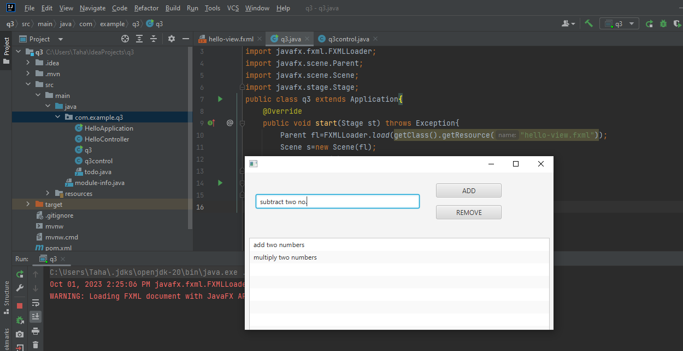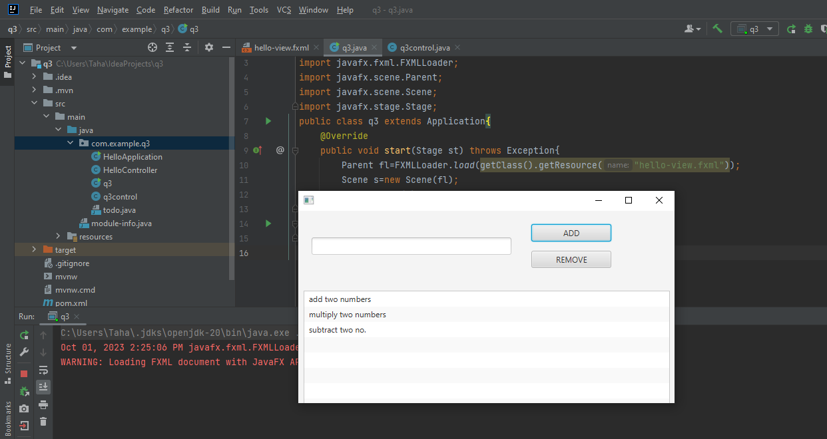

**Task 04**

package com.example.q4;  
  
import javafx.collections.FXCollections;  
import javafx.collections.ObservableList;  
import javafx.fxml.FXML;  
import javafx.fxml.Initializable;  
import javafx.scene.control.TableColumn;  
import javafx.scene.control.TableView;  
import javafx.scene.control.cell.PropertyValueFactory;  
import java.net.URL;  
import java.util.ResourceBundle;  
import javafx.scene.control.TextField;  
import javafx.event.ActionEvent;  
import javafx.scene.control.cell.TextFieldTableCell;  
public class q4control implements Initializable {  
 @FXML  
 private TableView<conm> t;  
 @FXML  
 private TableColumn<conm,String> e;  
 @FXML  
 private TableColumn<conm,String> n;  
 @FXML  
 private TableColumn<conm,String> p;  
 @FXML  
 private TextField txn;  
 @FXML  
 private TextField txe;  
 @FXML  
 private TextField txp;  
 ObservableList<conm>l=FXCollections.*observableArrayList*(  
 new conm("taha","12346544","taha@.com"),  
 new conm("ali","09878978765","hello.com") );  
 @Override  
 public void initialize(URL url, ResourceBundle resourceBundle){  
 n.setCellValueFactory(new PropertyValueFactory<conm,String>("tname"));  
 p.setCellValueFactory(new PropertyValueFactory<conm,String>("tphone"));  
 e.setCellValueFactory(new PropertyValueFactory<conm,String>("temail"));  
 t.setItems(l);  
 t.setEditable(true);  
 n.setCellFactory(TextFieldTableCell.*forTableColumn*());  
 p.setCellFactory(TextFieldTableCell.*forTableColumn*());  
 e.setCellFactory(TextFieldTableCell.*forTableColumn*()); }  
 @FXML  
 void add(ActionEvent ae){  
 String na=txn.getText().toString();  
 String ph=txp.getText().toString();  
 String em=txe.getText().toString();  
 conm c=new conm(na,ph,em);  
 t.getItems().add(c);  
 txn.setText("");  
 txp.setText("");  
 txe.setText(""); }  
 @FXML  
 void delete(ActionEvent ae){  
 ObservableList<conm> allproduct,singleproduct;  
 allproduct=t.getItems();  
 singleproduct=t.getSelectionModel().getSelectedItems();  
 singleproduct.forEach(allproduct::remove); }  
 @FXML  
 void edit(ActionEvent ae){}  
 @FXML  
 void click(TableColumn.CellEditEvent<conm,String> productString) {  
 conm c=t.getSelectionModel().getSelectedItem();  
 c.setTname(productString.getNewValue()); }  
 @FXML  
 void e_email(TableColumn.CellEditEvent<conm,String> productString) {  
 conm c=t.getSelectionModel().getSelectedItem();  
 c.setTemail(productString.getNewValue()); }  
 @FXML  
 void e_phone(TableColumn.CellEditEvent<conm,String> productString) {  
 conm c=t.getSelectionModel().getSelectedItem();  
 c.setTphone(productString.getNewValue()); }  
}

package com.example.q4;  
public class conm{  
 String n,p,e;  
 conm(String n,String p,String e){  
 this.n=n;  
 this.p=p;  
 this.e=e; }  
 public String getTname(){  
 return n; }  
 public void setTname(String n){  
 this.n=n; }  
 public String getTphone(){  
 return p; }  
 public void setTphone(String p){  
 this.p=p; }  
 public String getTemail(){  
 return e; }  
 public void setTemail(String e){  
 this.e=e; }  
}

